**APEX Alpha High Altitude Balloon Launch by Sutton Grammar School for Boys. Saturday 22nd October 2011. Churchill College, Cambridge.**

The APEX team is a group of teenagers who are passionate about electronics, technology and engineering.

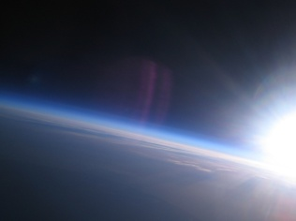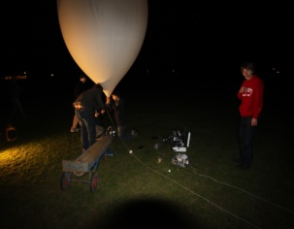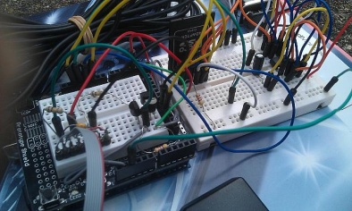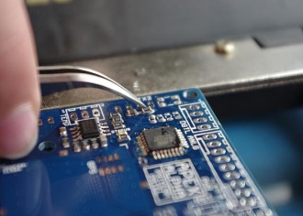

**Background**

The Apex High Altitude Balloon Project aims to use meteorological balloons to take photographs, capture video and collect sensor data from near-space. To date there have been two versions of Apex and three launches in total. On the 22nd October 2011 at 11am there will be a fourth launch with a new, very light payload; the aim is to break the current UK amateur altitude record for a weather balloon flight. Photos of this launch and the team will be available immediately after.

Weather balloons typically reach altitudes of 120,000ft, beyond the troposphere and into the stratosphere; this is 3½ times the altitude of a commercial aeroplane. The ApexHAB team aim to exceed this height and reach 4 times the altitude of a commercial flight.

The Apex High Altitude Balloon Project has been running since September 2008. It is being run by pupils at Sutton Grammar School for Boys. The boys running the project range in age from 15-17 and are named: Priyesh Patel, Daniel Saul, Edward Branford, Philip Warren, Alex Landless, Michael Woodgate and Alex Wakefield.

**Launch – Sat 22nd Oct**

APEX Alpha, the team’s newest payload will be launched for the first time. Weighing under 275g, it is extremely light with the electronics themselves weighing in at only 36g – sensors on the PCB, designed entirely by the students; include internal and external temperature and GPS co-ordinates and altitude. This data is then relayed to the team via a small radio module which is then picked up on an amateur radio set and fed into a software decoder on the team’s laptops. APEX Alpha is designed to become the core module of our next big payload, APEX III, developed from the ground up to be modular and efficient.

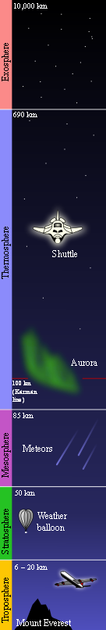**Funding**

The Balloon has been completely self-built by pupils in the school and has been funded by the Institute of Physics, Virgin Galactic, AFCEA (Armed Forces Communications and Electronics Association.), Dorking and District Radio Society, the school’s Curriculum Enrichment Group and the school PTA. The team is once again actively looking for sponsorship.

**Previous achievements**

Previous launches’ data and photographs are available online at [www.apexhab.org](http://www.apexhab.org) including photographs and video footage of sunrise taken above 90,000ft. At this altitude the layers of the Earth’s atmosphere are clearly visible.

**Future work**

The team will be entering into the National Science and Engineering Competition and hope to gain a place in the finals at the Big Bang Fair in March 2012. There is also another planned launch for Spring 2012 of APEX III carrying instruments capable of measuring radiation levels at varying altitudes, light levels, various gas sensors such as CO2, an ash sensor which could collect interesting data in the event of another volcanic eruption affecting the UK, a pressure sensor, higher resolution cameras and our HD Video Camera.

For more information, please email [team@apexhab.org](mailto:team@apexhab.org)or contact Sutton Grammar School for Boys.